Qt Development Documentation

Opencv Ubuntu setup guide:
https://docs.opencv.org/3.4.2/d7/d9f/tutorial_linux_install.html – the guide used in project.

Qt Creator:
Link: https://download.qt.io/archive/qt/5.12/5.12.12/
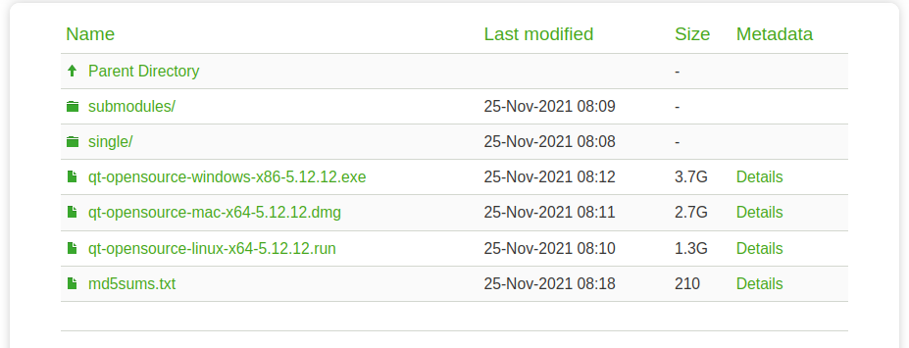
After downloading qt-opensource-linux-x64-5.12.12.run, open terminal and run command:

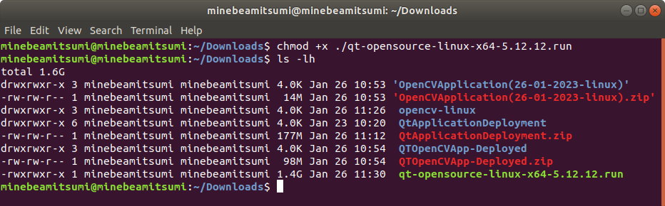
chmod +x qt-opensource-linux-x64-5.12.12.run
Note: Color green font indicates executable file.

Link opencv to Qt Creator. Modify .pro file from your Qt Project
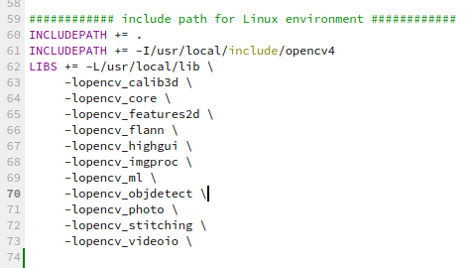

Qt Application Deployment on Linux Environment

Guide:
https://medium.com/swlh/how-to-deploy-your-qt-applications-to-linux-operating-system-with-linuxdeployqt-3c004a43c67a

Download linuxdeployqt: https://github.com/probonopd/linuxdeployqt
Read Documentation before doing the process.
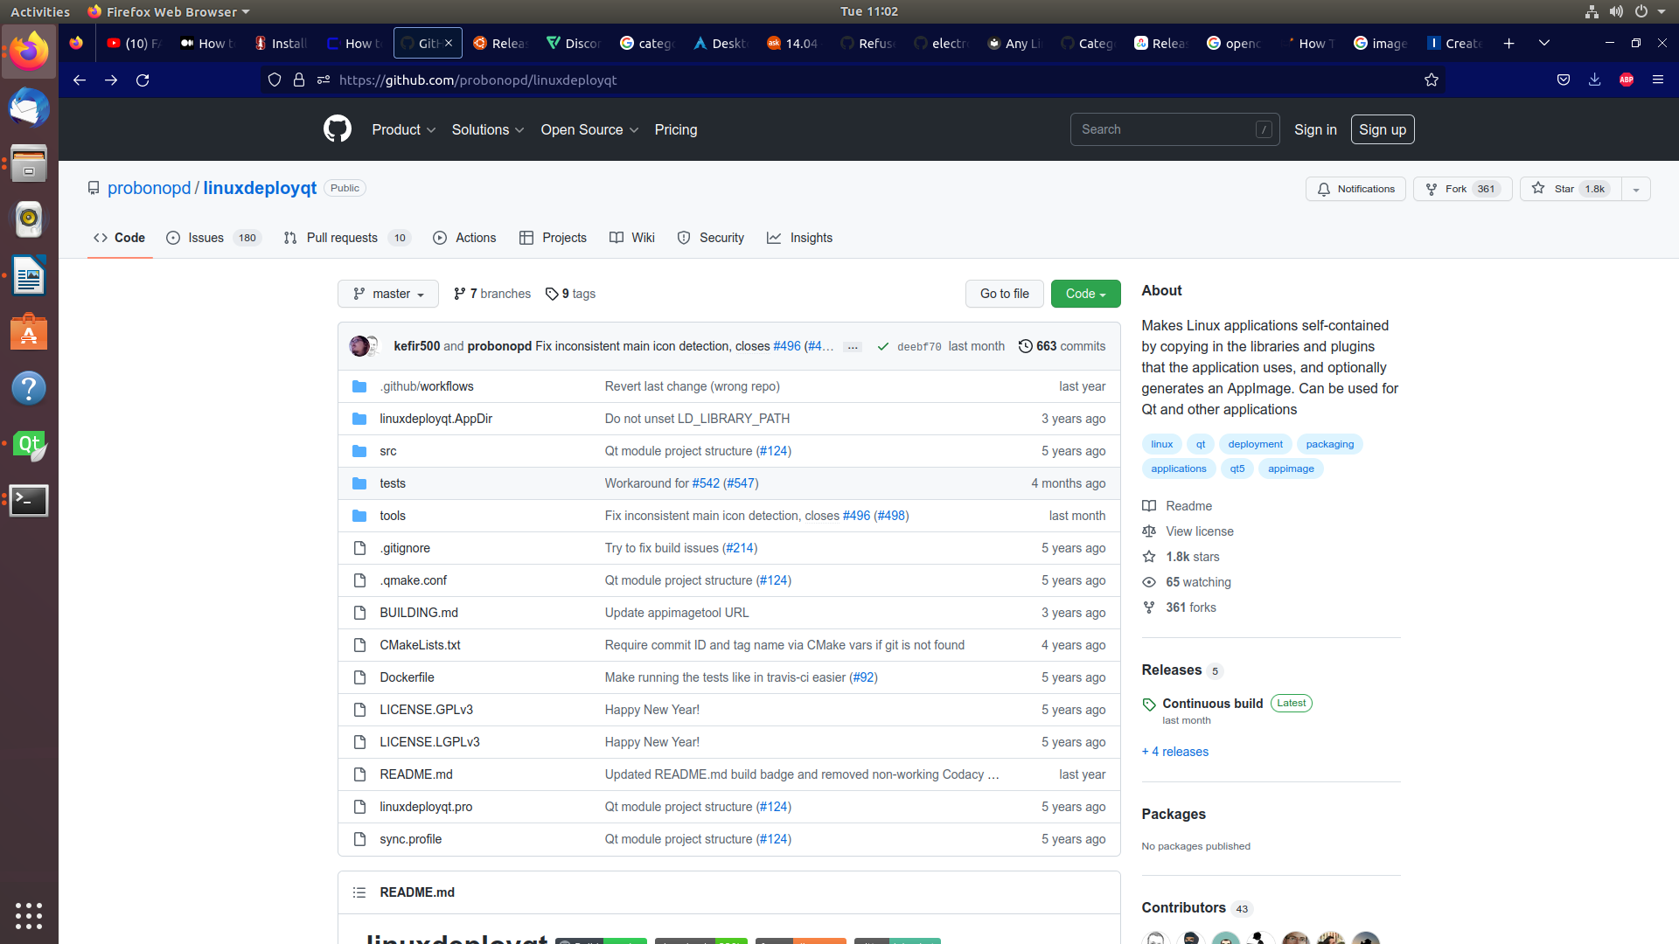

For Ubuntu 22.04
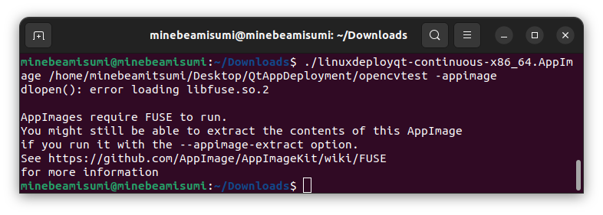
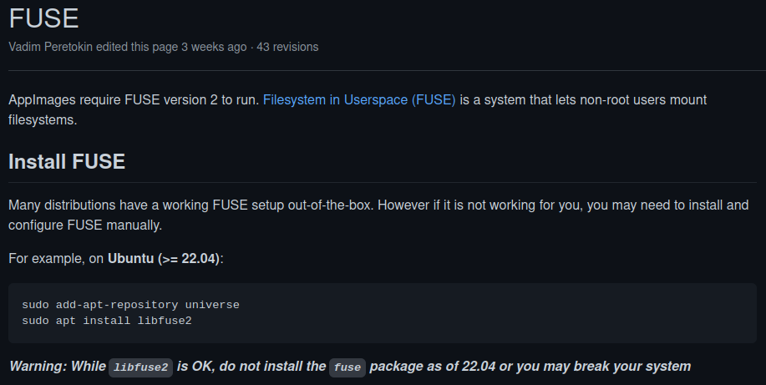
Download FUSE: https://github.com/AppImage/AppImageKit/wiki/FUSE

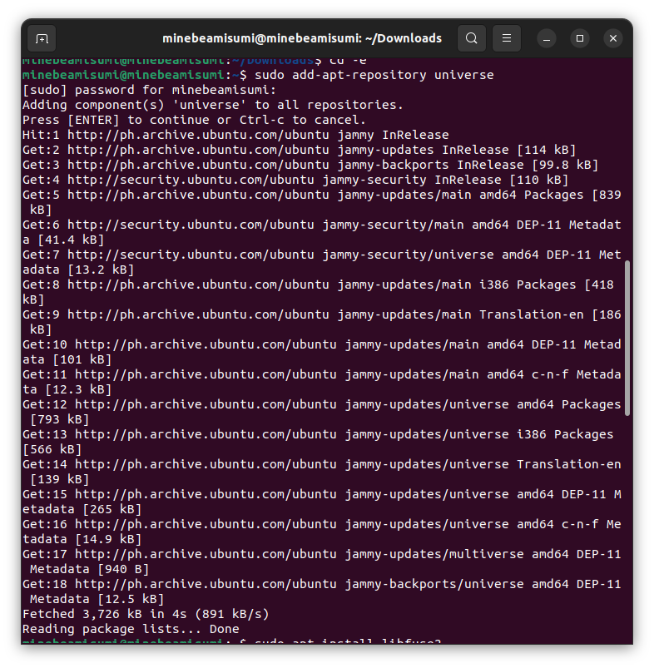
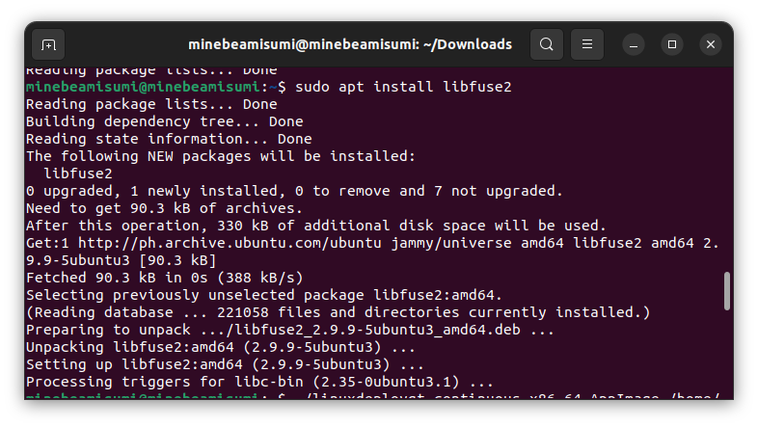

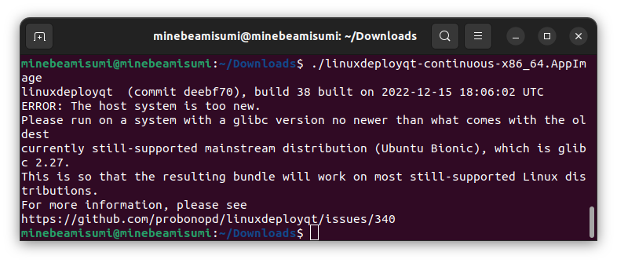
Due to warning note and compatibility, the deployment of the app is decided to deploy on the lower version of Ubuntu since the deployment on lower version last time is successfull.

UBUNTU 18.04
Error Path in deployment:
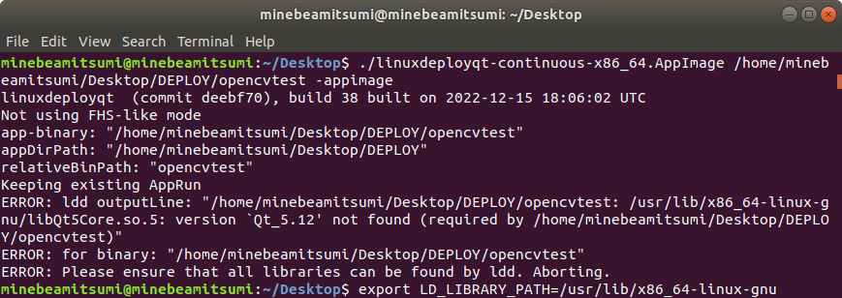
Run command:
My custom path (export PATH=/home/minebeamitsumi/Qt5.12.12/5.12.12/gcc_64/bin/:$PATH)

OUTPUT:

minebeamitsumi@minebeamitsumi:~/Desktop$ ./linuxdeployqt-continuous-x86_64.AppImage /home/minebeamitsumi/Desktop/DEPLOY/opencvtest -appimage
linuxdeployqt (commit deebf70), build 38 built on 2022-12-15 18:06:02 UTC
Not using FHS-like mode
app-binary: "/home/minebeamitsumi/Desktop/DEPLOY/opencvtest"
appDirPath: "/home/minebeamitsumi/Desktop/DEPLOY"
relativeBinPath: "opencvtest"
Keeping existing AppRun
WARNING: "/home/minebeamitsumi/Desktop/DEPLOY/qt.conf" already exists, will not overwrite.
ERROR: lconvert not found at "/tmp/.mount_linuxdjOKRUX/usr/bin/lconvert"
ERROR: Failed to copy translations
appimagetool, continuous build (commit 8bbf694), build <local dev build> built on 2020-12-31 11:48:33 UTC
fatal: not a git repository (or any of the parent directories): .git
Failed to run 'git rev-parse --short HEAD: Child process exited with code 128 (code 128)
Desktop file: /home/minebeamitsumi/Desktop/DEPLOY/desktop.desktop
Name: OpenCVApplication
Icon: icon
Exec: OpenCVApp
Comment: Qt Application Deployment
Type: Application
Categories: Development;
/home/minebeamitsumi/Desktop/DEPLOY/lib/libQt5Quick.so.5 used for determining architecture x86_64
/home/minebeamitsumi/Desktop/DEPLOY/lib/libdatrie.so.1 used for determining architecture x86_64
/home/minebeamitsumi/Desktop/DEPLOY/lib/libx265.so.146 used for determining architecture x86_64
/home/minebeamitsumi/Desktop/DEPLOY/lib/liborc-0.4.so.0 used for determining architecture x86_64
/home/minebeamitsumi/Desktop/DEPLOY/lib/libpangoft2-1.0.so.0 used for determining architecture x86_64
/home/minebeamitsumi/Desktop/DEPLOY/lib/libQt5Network.so.5 used for determining architecture x86_64
/home/minebeamitsumi/Desktop/DEPLOY/lib/libopenjp2.so.7 used for determining architecture x86_64
/home/minebeamitsumi/Desktop/DEPLOY/lib/libswresample.so.2 used for determining architecture x86_64
/home/minebeamitsumi/Desktop/DEPLOY/lib/libgme.so.0 used for determining architecture x86_64
/home/minebeamitsumi/Desktop/DEPLOY/lib/libzvbi.so.0 used for determining architecture x86_64
/home/minebeamitsumi/Desktop/DEPLOY/lib/libvorbisfile.so.3 used for determining architecture x86_64
/home/minebeamitsumi/Desktop/DEPLOY/lib/libjpeg.so.8 used for determining architecture x86_64
/home/minebeamitsumi/Desktop/DEPLOY/lib/libopencv_flann.so.407 used for determining architecture x86_64
/home/minebeamitsumi/Desktop/DEPLOY/lib/libQt5Widgets.so.5 used for determining architecture x86_64
/home/minebeamitsumi/Desktop/DEPLOY/lib/libtheoradec.so.1 used for determining architecture x86_64
/home/minebeamitsumi/Desktop/DEPLOY/lib/libxcb-xkb.so.1 used for determining architecture x86_64
/home/minebeamitsumi/Desktop/DEPLOY/lib/libgsm.so.1 used for determining architecture x86_64
/home/minebeamitsumi/Desktop/DEPLOY/lib/libtasn1.so.6 used for determining architecture x86_64
/home/minebeamitsumi/Desktop/DEPLOY/lib/libxml2.so.2 used for determining architecture x86_64
/home/minebeamitsumi/Desktop/DEPLOY/lib/libvdpau.so.1 used for determining architecture x86_64
/home/minebeamitsumi/Desktop/DEPLOY/lib/libwavpack.so.1 used for determining architecture x86_64
/home/minebeamitsumi/Desktop/DEPLOY/lib/libffi.so.6 used for determining architecture x86_64
/home/minebeamitsumi/Desktop/DEPLOY/lib/libpangocairo-1.0.so.0 used for determining architecture x86_64
/home/minebeamitsumi/Desktop/DEPLOY/lib/libhogweed.so.4 used for determining architecture x86_64
/home/minebeamitsumi/Desktop/DEPLOY/lib/libshine.so.3 used for determining architecture x86_64
/home/minebeamitsumi/Desktop/DEPLOY/lib/libopencv_core.so.407 used for determining architecture x86_64
/home/minebeamitsumi/Desktop/DEPLOY/lib/libXau.so.6 used for determining architecture x86_64
/home/minebeamitsumi/Desktop/DEPLOY/lib/librsvg-2.so.2 used for determining architecture x86_64
/home/minebeamitsumi/Desktop/DEPLOY/lib/libavutil.so.55 used for determining architecture x86_64
/home/minebeamitsumi/Desktop/DEPLOY/lib/libxcb-render.so.0 used for determining architecture x86_64
/home/minebeamitsumi/Desktop/DEPLOY/lib/libX11-xcb.so.1 used for determining architecture x86_64
/home/minebeamitsumi/Desktop/DEPLOY/lib/libXrender.so.1 used for determining architecture x86_64
/home/minebeamitsumi/Desktop/DEPLOY/lib/libglib-2.0.so.0 used for determining architecture x86_64
/home/minebeamitsumi/Desktop/DEPLOY/lib/libQt5Core.so.5 used for determining architecture x86_64
/home/minebeamitsumi/Desktop/DEPLOY/lib/libXfixes.so.3 used for determining architecture x86_64
/home/minebeamitsumi/Desktop/DEPLOY/lib/libtheoraenc.so.1 used for determining architecture x86_64
/home/minebeamitsumi/Desktop/DEPLOY/lib/libnuma.so.1 used for determining architecture x86_64
/home/minebeamitsumi/Desktop/DEPLOY/lib/libopenmpt.so.0 used for determining architecture x86_64
/home/minebeamitsumi/Desktop/DEPLOY/lib/libopencv_features2d.so.407 used for determining architecture x86_64
/home/minebeamitsumi/Desktop/DEPLOY/lib/libgobject-2.0.so.0 used for determining architecture x86_64
/home/minebeamitsumi/Desktop/DEPLOY/lib/libtwolame.so.0 used for determining architecture x86_64
/home/minebeamitsumi/Desktop/DEPLOY/lib/libopus.so.0 used for determining architecture x86_64
/home/minebeamitsumi/Desktop/DEPLOY/lib/libQt5Svg.so.5 used for determining architecture x86_64
/home/minebeamitsumi/Desktop/DEPLOY/lib/libgthread-2.0.so.0 used for determining architecture x86_64
/home/minebeamitsumi/Desktop/DEPLOY/lib/libgio-2.0.so.0 used for determining architecture x86_64
/home/minebeamitsumi/Desktop/DEPLOY/lib/libicudata.so.56 used for determining architecture x86_64
/home/minebeamitsumi/Desktop/DEPLOY/lib/libnettle.so.6 used for determining architecture x86_64
/home/minebeamitsumi/Desktop/DEPLOY/lib/libQt5Multimedia.so.5 used for determining architecture x86_64
/home/minebeamitsumi/Desktop/DEPLOY/lib/libsystemd.so.0 used for determining architecture x86_64
/home/minebeamitsumi/Desktop/DEPLOY/lib/libgraphite2.so.3 used for determining architecture x86_64
/home/minebeamitsumi/Desktop/DEPLOY/lib/libgstreamer-1.0.so.0 used for determining architecture x86_64
/home/minebeamitsumi/Desktop/DEPLOY/lib/libgnutls.so.30 used for determining architecture x86_64
/home/minebeamitsumi/Desktop/DEPLOY/lib/libFLAC.so.8 used for determining architecture x86_64
/home/minebeamitsumi/Desktop/DEPLOY/lib/libgstpbutils-1.0.so.0 used for determining architecture x86_64
/home/minebeamitsumi/Desktop/DEPLOY/lib/libxcb-glx.so.0 used for determining architecture x86_64
/home/minebeamitsumi/Desktop/DEPLOY/lib/libsndfile.so.1 used for determining architecture x86_64
/home/minebeamitsumi/Desktop/DEPLOY/lib/libgmodule-2.0.so.0 used for determining architecture x86_64
/home/minebeamitsumi/Desktop/DEPLOY/lib/libwrap.so.0 used for determining architecture x86_64
/home/minebeamitsumi/Desktop/DEPLOY/lib/libvpx.so.5 used for determining architecture x86_64
/home/minebeamitsumi/Desktop/DEPLOY/lib/libvorbis.so.0 used for determining architecture x86_64
/home/minebeamitsumi/Desktop/DEPLOY/lib/libmpg123.so.0 used for determining architecture x86_64
/home/minebeamitsumi/Desktop/DEPLOY/lib/libicuuc.so.60 used for determining architecture x86_64
/home/minebeamitsumi/Desktop/DEPLOY/lib/libswscale.so.4 used for determining architecture x86_64
/home/minebeamitsumi/Desktop/DEPLOY/lib/libQt5XcbQpa.so.5 used for determining architecture x86_64
/home/minebeamitsumi/Desktop/DEPLOY/lib/liblz4.so.1 used for determining architecture x86_64
/home/minebeamitsumi/Desktop/DEPLOY/lib/libselinux.so.1 used for determining architecture x86_64
/home/minebeamitsumi/Desktop/DEPLOY/lib/libicuuc.so.56 used for determining architecture x86_64
/home/minebeamitsumi/Desktop/DEPLOY/lib/libgstvideo-1.0.so.0 used for determining architecture x86_64
/home/minebeamitsumi/Desktop/DEPLOY/lib/libsoxr.so.0 used for determining architecture x86_64
/home/minebeamitsumi/Desktop/DEPLOY/lib/libunistring.so.2 used for determining architecture x86_64
/home/minebeamitsumi/Desktop/DEPLOY/lib/libwebp.so.6 used for determining architecture x86_64
/home/minebeamitsumi/Desktop/DEPLOY/lib/libblkid.so.1 used for determining architecture x86_64
/home/minebeamitsumi/Desktop/DEPLOY/lib/libva-x11.so.2 used for determining architecture x86_64
/home/minebeamitsumi/Desktop/DEPLOY/lib/libx264.so.152 used for determining architecture x86_64
/home/minebeamitsumi/Desktop/DEPLOY/lib/libapparmor.so.1 used for determining architecture x86_64
/home/minebeamitsumi/Desktop/DEPLOY/lib/libk5crypto.so.3 used for determining architecture x86_64
/home/minebeamitsumi/Desktop/DEPLOY/lib/libQt5OpenGL.so.5 used for determining architecture x86_64
/home/minebeamitsumi/Desktop/DEPLOY/lib/libQt5VirtualKeyboard.so.5 used for determining architecture x86_64
/home/minebeamitsumi/Desktop/DEPLOY/lib/libicui18n.so.56 used for determining architecture x86_64
/home/minebeamitsumi/Desktop/DEPLOY/lib/libwebpmux.so.3 used for determining architecture x86_64
/home/minebeamitsumi/Desktop/DEPLOY/lib/libmount.so.1 used for determining architecture x86_64
/home/minebeamitsumi/Desktop/DEPLOY/lib/libpulse-mainloop-glib.so.0 used for determining architecture x86_64
/home/minebeamitsumi/Desktop/DEPLOY/lib/libcairo.so.2 used for determining architecture x86_64
/home/minebeamitsumi/Desktop/DEPLOY/lib/libgstaudio-1.0.so.0 used for determining architecture x86_64
/home/minebeamitsumi/Desktop/DEPLOY/lib/libQt5DBus.so.5 used for determining architecture x86_64
/home/minebeamitsumi/Desktop/DEPLOY/lib/liblzma.so.5 used for determining architecture x86_64
/home/minebeamitsumi/Desktop/DEPLOY/lib/libbz2.so.1.0 used for determining architecture x86_64
/home/minebeamitsumi/Desktop/DEPLOY/lib/libgstbase-1.0.so.0 used for determining architecture x86_64
/home/minebeamitsumi/Desktop/DEPLOY/lib/libxkbcommon.so.0 used for determining architecture x86_64
/home/minebeamitsumi/Desktop/DEPLOY/lib/libvorbisenc.so.2 used for determining architecture x86_64
/home/minebeamitsumi/Desktop/DEPLOY/lib/libopencv_imgcodecs.so.407 used for determining architecture x86_64
/home/minebeamitsumi/Desktop/DEPLOY/lib/libbsd.so.0 used for determining architecture x86_64
/home/minebeamitsumi/Desktop/DEPLOY/lib/libcroco-0.6.so.3 used for determining architecture x86_64
/home/minebeamitsumi/Desktop/DEPLOY/lib/libpango-1.0.so.0 used for determining architecture x86_64
/home/minebeamitsumi/Desktop/DEPLOY/lib/libQt5MultimediaGstTools.so.5 used for determining architecture x86_64
/home/minebeamitsumi/Desktop/DEPLOY/lib/libxkbcommon-x11.so.0 used for determining architecture x86_64
/home/minebeamitsumi/Desktop/DEPLOY/lib/libssh-gcrypt.so.4 used for determining architecture x86_64
/home/minebeamitsumi/Desktop/DEPLOY/lib/libxcb-xfixes.so.0 used for determining architecture x86_64
/home/minebeamitsumi/Desktop/DEPLOY/lib/libopencv_imgproc.so.407 used for determining architecture x86_64
/home/minebeamitsumi/Desktop/DEPLOY/lib/libavformat.so.57 used for determining architecture x86_64
/home/minebeamitsumi/Desktop/DEPLOY/lib/libxvidcore.so.4 used for determining architecture x86_64
/home/minebeamitsumi/Desktop/DEPLOY/lib/libspeex.so.1 used for determining architecture x86_64
/home/minebeamitsumi/Desktop/DEPLOY/lib/libgstapp-1.0.so.0 used for determining architecture x86_64
/home/minebeamitsumi/Desktop/DEPLOY/lib/libQt5MultimediaWidgets.so.5 used for determining architecture x86_64
/home/minebeamitsumi/Desktop/DEPLOY/lib/libva-drm.so.2 used for determining architecture x86_64
/home/minebeamitsumi/Desktop/DEPLOY/lib/libgcrypt.so.20 used for determining architecture x86_64
/home/minebeamitsumi/Desktop/DEPLOY/lib/libXdmcp.so.6 used for determining architecture x86_64
/home/minebeamitsumi/Desktop/DEPLOY/lib/libsnappy.so.1 used for determining architecture x86_64
/home/minebeamitsumi/Desktop/DEPLOY/lib/libbluray.so.2 used for determining architecture x86_64
/home/minebeamitsumi/Desktop/DEPLOY/lib/libkrb5.so.3 used for determining architecture x86_64
/home/minebeamitsumi/Desktop/DEPLOY/lib/libkeyutils.so.1 used for determining architecture x86_64
/home/minebeamitsumi/Desktop/DEPLOY/lib/libgdk_pixbuf-2.0.so.0 used for determining architecture x86_64
/home/minebeamitsumi/Desktop/DEPLOY/lib/libpixman-1.so.0 used for determining architecture x86_64
/home/minebeamitsumi/Desktop/DEPLOY/lib/libpulse.so.0 used for determining architecture x86_64
/home/minebeamitsumi/Desktop/DEPLOY/lib/libmp3lame.so.0 used for determining architecture x86_64
/home/minebeamitsumi/Desktop/DEPLOY/lib/libgsttag-1.0.so.0 used for determining architecture x86_64
/home/minebeamitsumi/Desktop/DEPLOY/lib/libnsl.so.1 used for determining architecture x86_64
/home/minebeamitsumi/Desktop/DEPLOY/lib/libdbus-1.so.3 used for determining architecture x86_64
/home/minebeamitsumi/Desktop/DEPLOY/lib/libXext.so.6 used for determining architecture x86_64
/home/minebeamitsumi/Desktop/DEPLOY/lib/libkrb5support.so.0 used for determining architecture x86_64
/home/minebeamitsumi/Desktop/DEPLOY/lib/libgssapi_krb5.so.2 used for determining architecture x86_64
/home/minebeamitsumi/Desktop/DEPLOY/lib/libchromaprint.so.1 used for determining architecture x86_64
/home/minebeamitsumi/Desktop/DEPLOY/lib/libidn2.so.0 used for determining architecture x86_64
/home/minebeamitsumi/Desktop/DEPLOY/lib/libQt5Gui.so.5 used for determining architecture x86_64
/home/minebeamitsumi/Desktop/DEPLOY/lib/libicudata.so.60 used for determining architecture x86_64
/home/minebeamitsumi/Desktop/DEPLOY/lib/libpcre.so.3 used for determining architecture x86_64
/home/minebeamitsumi/Desktop/DEPLOY/lib/libQt5Qml.so.5 used for determining architecture x86_64
/home/minebeamitsumi/Desktop/DEPLOY/lib/libcrystalhd.so.3 used for determining architecture x86_64
/home/minebeamitsumi/Desktop/DEPLOY/lib/libxcb-shm.so.0 used for determining architecture x86_64
/home/minebeamitsumi/Desktop/DEPLOY/lib/libavcodec.so.57 used for determining architecture x86_64
/home/minebeamitsumi/Desktop/DEPLOY/lib/libasyncns.so.0 used for determining architecture x86_64
/home/minebeamitsumi/Desktop/DEPLOY/lib/libopencv_videoio.so.407 used for determining architecture x86_64
/home/minebeamitsumi/Desktop/DEPLOY/lib/libpng16.so.16 used for determining architecture x86_64
/home/minebeamitsumi/Desktop/DEPLOY/lib/libogg.so.0 used for determining architecture x86_64
/home/minebeamitsumi/Desktop/DEPLOY/lib/libgomp.so.1 used for determining architecture x86_64
/home/minebeamitsumi/Desktop/DEPLOY/lib/libva.so.2 used for determining architecture x86_64
/home/minebeamitsumi/Desktop/DEPLOY/opencvtest used for determining architecture x86_64
/home/minebeamitsumi/Desktop/DEPLOY/OpenCVApplication-x86_64.AppImage used for determining architecture x86_64
/home/minebeamitsumi/Desktop/DEPLOY/plugins/iconengines/libqsvgicon.so used for determining architecture x86_64
/home/minebeamitsumi/Desktop/DEPLOY/plugins/platforms/libqxcb.so used for determining architecture x86_64
/home/minebeamitsumi/Desktop/DEPLOY/plugins/mediaservice/libgstmediacapture.so used for determining architecture x86_64
/home/minebeamitsumi/Desktop/DEPLOY/plugins/mediaservice/libgstaudiodecoder.so used for determining architecture x86_64
/home/minebeamitsumi/Desktop/DEPLOY/plugins/mediaservice/libgstmediaplayer.so used for determining architecture x86_64
/home/minebeamitsumi/Desktop/DEPLOY/plugins/mediaservice/libgstcamerabin.so used for determining architecture x86_64
/home/minebeamitsumi/Desktop/DEPLOY/plugins/bearer/libqnmbearer.so used for determining architecture x86_64
/home/minebeamitsumi/Desktop/DEPLOY/plugins/bearer/libqgenericbearer.so used for determining architecture x86_64
/home/minebeamitsumi/Desktop/DEPLOY/plugins/bearer/libqconnmanbearer.so used for determining architecture x86_64
/home/minebeamitsumi/Desktop/DEPLOY/plugins/imageformats/libqtga.so used for determining architecture x86_64
/home/minebeamitsumi/Desktop/DEPLOY/plugins/imageformats/libqtiff.so used for determining architecture x86_64
/home/minebeamitsumi/Desktop/DEPLOY/plugins/imageformats/libqwbmp.so used for determining architecture x86_64
/home/minebeamitsumi/Desktop/DEPLOY/plugins/imageformats/libqico.so used for determining architecture x86_64
/home/minebeamitsumi/Desktop/DEPLOY/plugins/imageformats/libqsvg.so used for determining architecture x86_64
/home/minebeamitsumi/Desktop/DEPLOY/plugins/imageformats/libqwebp.so used for determining architecture x86_64
/home/minebeamitsumi/Desktop/DEPLOY/plugins/imageformats/libqicns.so used for determining architecture x86_64
/home/minebeamitsumi/Desktop/DEPLOY/plugins/imageformats/libqgif.so used for determining architecture x86_64
/home/minebeamitsumi/Desktop/DEPLOY/plugins/imageformats/libqjpeg.so used for determining architecture x86_64
/home/minebeamitsumi/Desktop/DEPLOY/plugins/platforminputcontexts/libcomposeplatforminputcontextplugin.so used for determining architecture x86_64
/home/minebeamitsumi/Desktop/DEPLOY/plugins/platforminputcontexts/libqtvirtualkeyboardplugin.so used for determining architecture x86_64
/home/minebeamitsumi/Desktop/DEPLOY/plugins/platforminputcontexts/libibusplatforminputcontextplugin.so used for determining architecture x86_64
/home/minebeamitsumi/Desktop/DEPLOY/plugins/xcbglintegrations/libqxcb-glx-integration.so used for determining architecture x86_64
/home/minebeamitsumi/Desktop/DEPLOY/plugins/xcbglintegrations/libqxcb-egl-integration.so used for determining architecture x86_64
/home/minebeamitsumi/Desktop/DEPLOY/plugins/audio/libqtaudio_alsa.so used for determining architecture x86_64
/home/minebeamitsumi/Desktop/DEPLOY/plugins/audio/libqtmedia_pulse.so used for determining architecture x86_64
Using architecture x86_64
App name for filename: OpenCVApplication
/home/minebeamitsumi/Desktop/DEPLOY should be packaged as OpenCVApplication-x86_64.AppImage
Generating squashfs...
Size of the embedded runtime: 189632 bytes
mksquashfs commandline: /tmp/.mount_linuxdjOKRUX/usr/bin/../lib/appimagekit/mksquashfs /home/minebeamitsumi/Desktop/DEPLOY OpenCVApplication-x86_64.AppImage -offset 189632 -comp gzip -root-owned -noappend -mkfs-time 0
Parallel mksquashfs: Using 4 processors
Creating 4.0 filesystem on OpenCVApplication-x86_64.AppImage, block size 131072.
[=============================================================|] 2631/2631 100%

Exportable Squashfs 4.0 filesystem, gzip compressed, data block size 131072
compressed data, compressed metadata, compressed fragments,
compressed xattrs, compressed ids
duplicates are removed
Filesystem size 173864.40 Kbytes (169.79 Mbytes)
55.73% of uncompressed filesystem size (311974.25 Kbytes)
Inode table size 10828 bytes (10.57 Kbytes)
46.87% of uncompressed inode table size (23100 bytes)
Directory table size 3946 bytes (3.85 Kbytes)
39.87% of uncompressed directory table size (9898 bytes)
Number of duplicate files found 22
Number of inodes 414
Number of files 296
Number of fragments 45
Number of symbolic links 2
Number of device nodes 0
Number of fifo nodes 0
Number of socket nodes 0
Number of directories 116
Number of ids (unique uids + gids) 1
Number of uids 1
root (0)
Number of gids 1
root (0)
Embedding ELF...
Marking the AppImage as executable...
Embedding MD5 digest
Success

Please consider submitting your AppImage to AppImageHub, the crowd-sourced
central directory of available AppImages, by opening a pull request
at https://github.com/AppImage/appimage.github.io
minebeamitsumi@minebeamitsumi:~/Desktop$
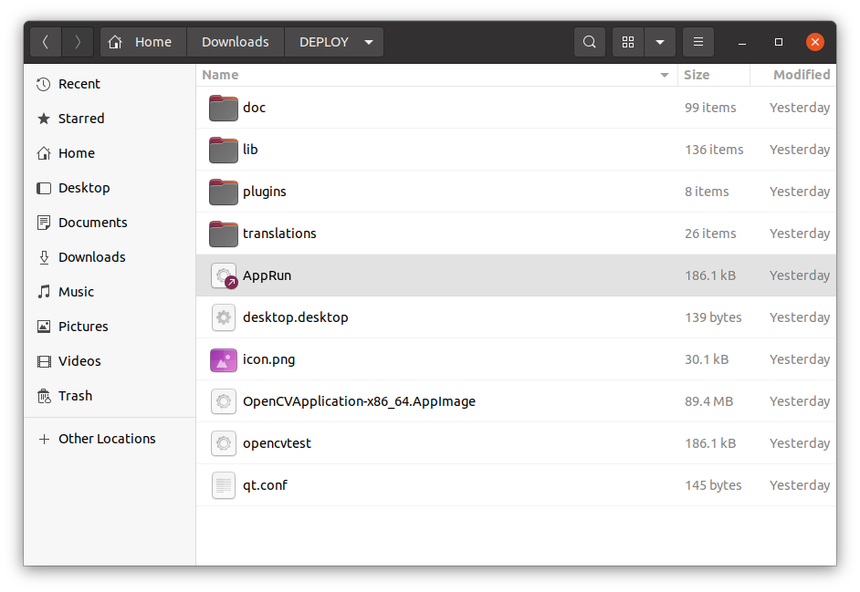
The DEPLOY folder shows the AppImage Bundle

UBUNTU 20.04

MainWindow UI:
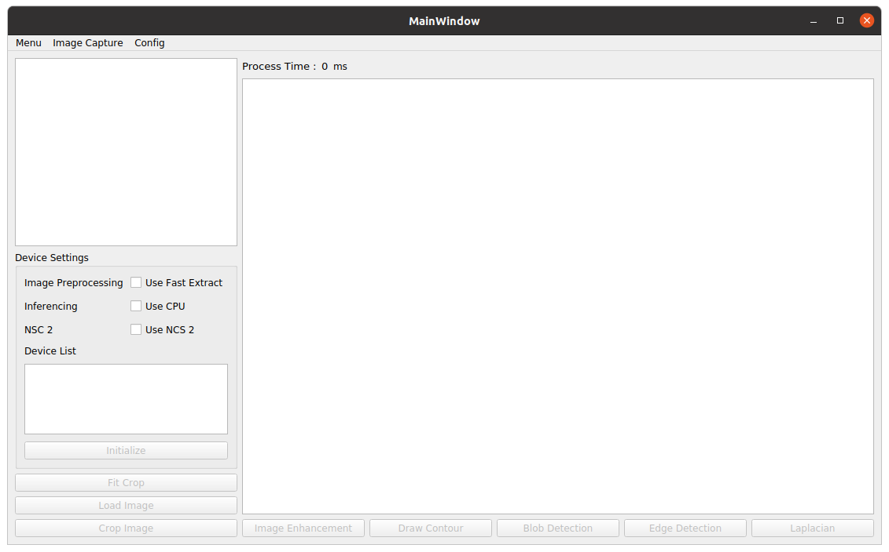
Menu:
- Menu – no functions made
- Image Capture – enable camera feed UI and display camera devices
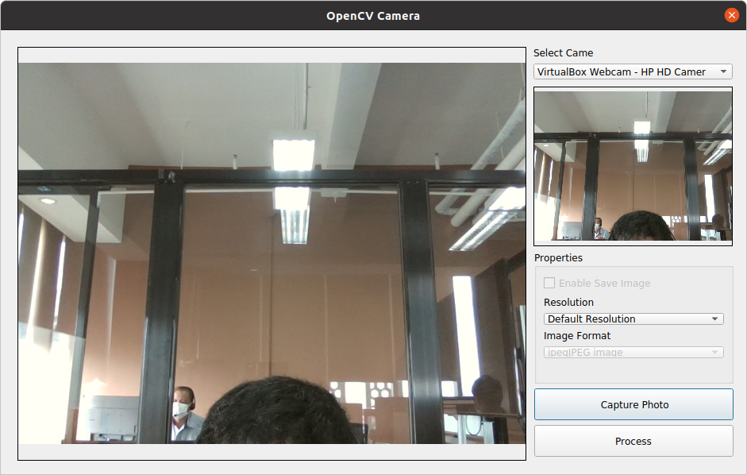

- Config – configure custom image processing (disabled functions)

Buttons:
- Crop Image
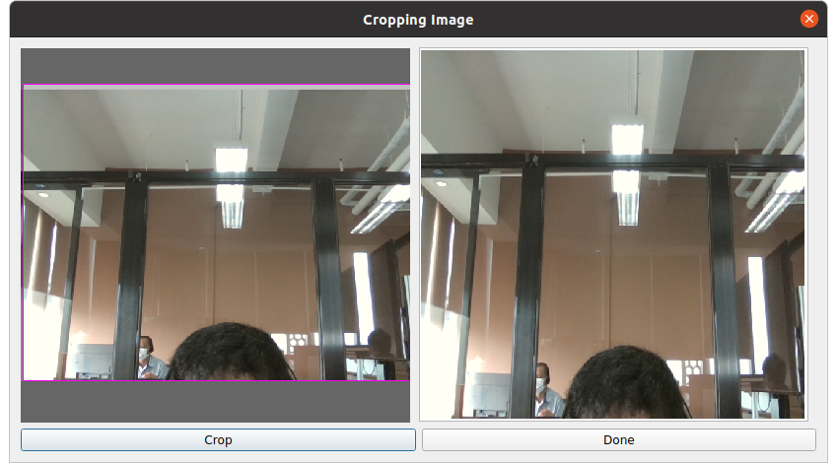

- Image Enhancement

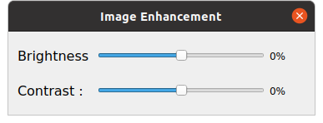

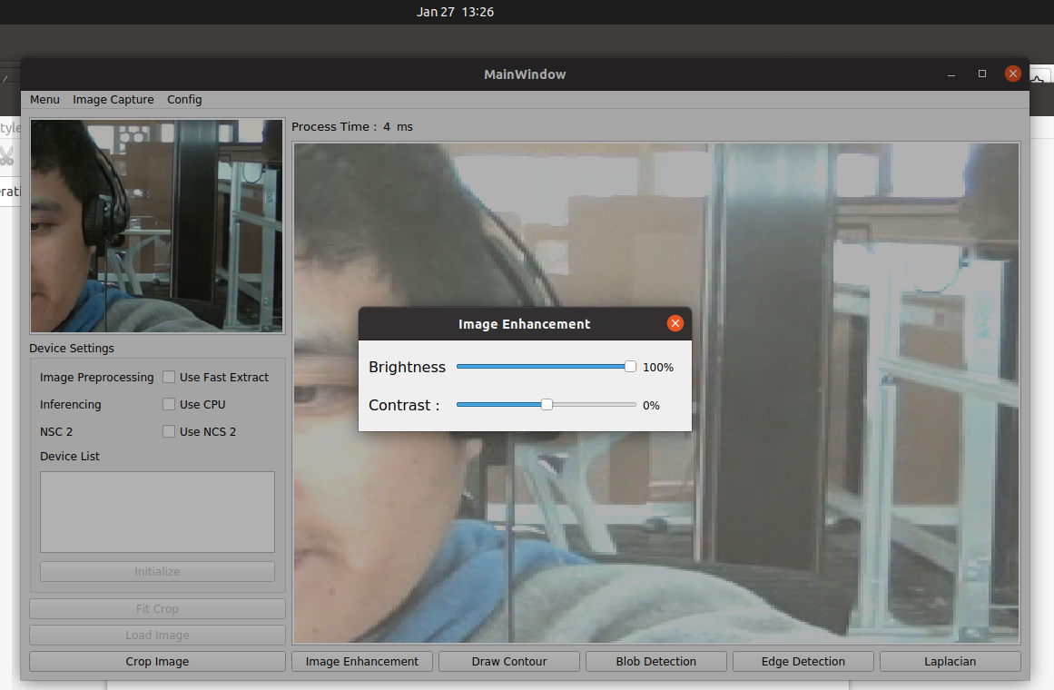
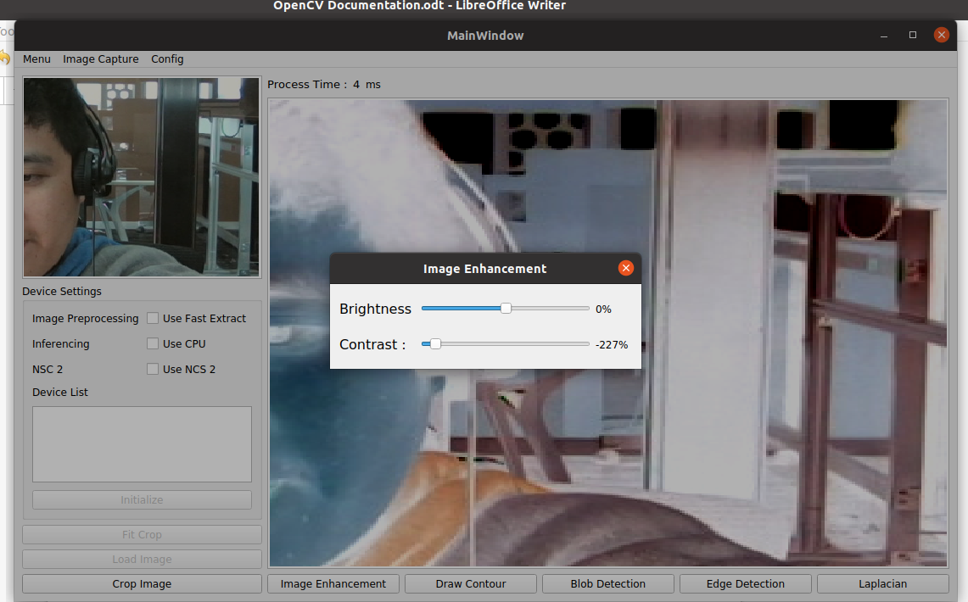

- Draw Contour
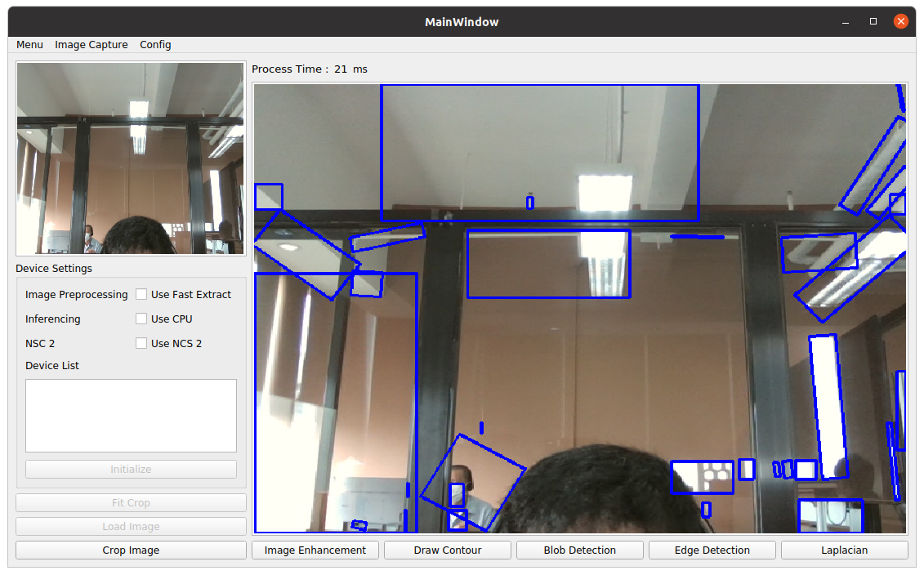

- Blob Detection
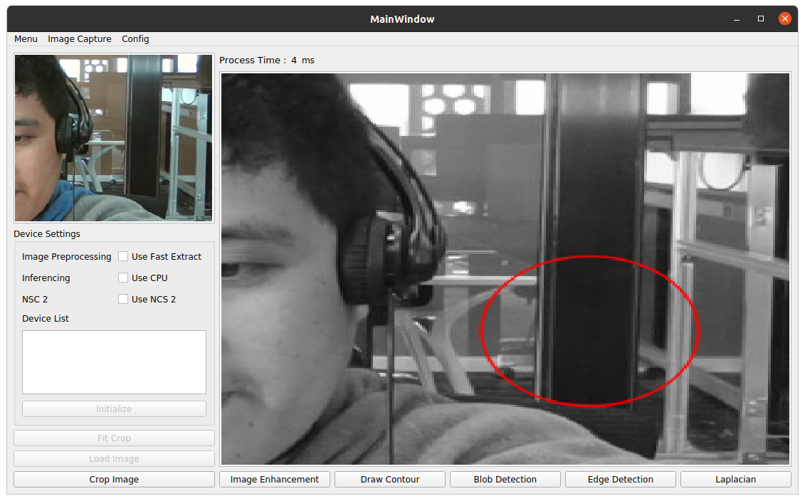

- Edge Detection
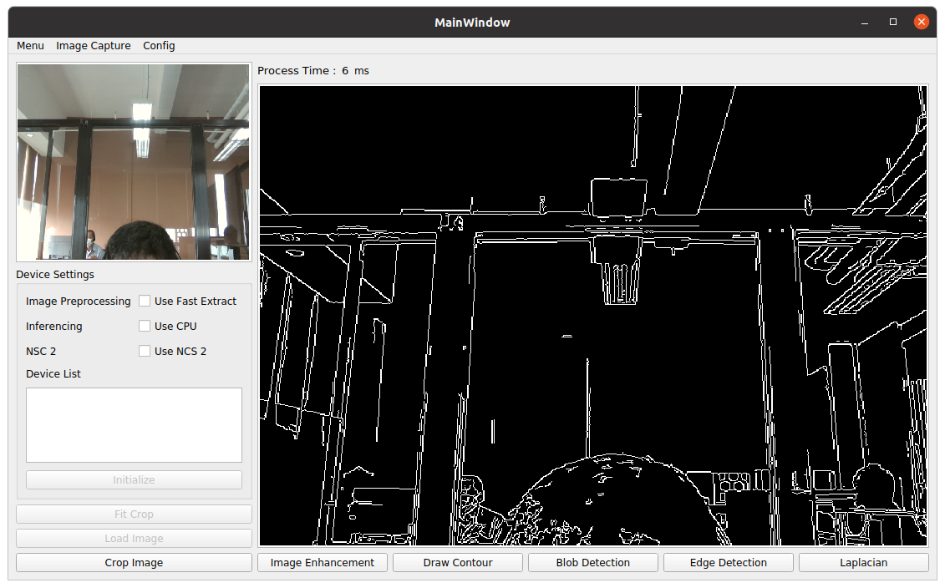

- Laplacian
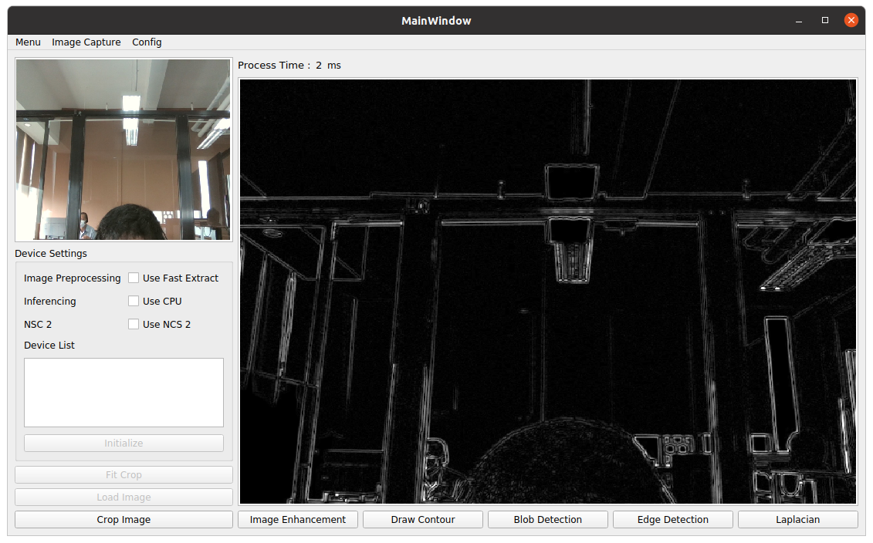

Note: Upon testing the deployed app that we created using the ubuntu environment on Rasberry Pi, it turns out unrunnable since we are using AppImage Deployment that only supports on Intel processors while Rasberry Pi uses ARM Processors.

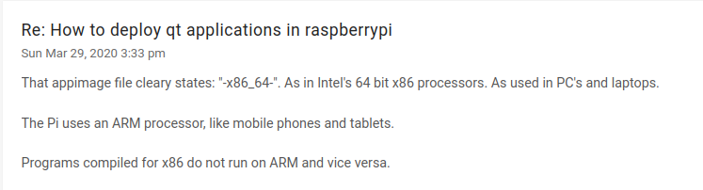

Links for Qt Cross Compilation for Raspberry Pi
https://www.youtube.com/watch?v=TmtN3Rmx9Rk&t=3s&ab_channel=UlasDikme
https://github.com/PhysicsX/QTonRaspberryPi/tree/main/QtRaspberryPi5.14.2

Note: Follow the youtube video on how to setup the Qt Creator for Cross Compilation on Raspberry Pi.

Download Links:
https://releases.linaro.org/components/toolchain/binaries/7.5-2019.12/arm-linux-gnueabihf/
https://download.qt.io/official_releases/qt/5.15/5.15.8/single/

Based on the links above, deployment on raspberry made possible. Using the camera app example from Qt Creator, we made a deployment on raspberry pi device.

Goto Projects: Copy build release directory
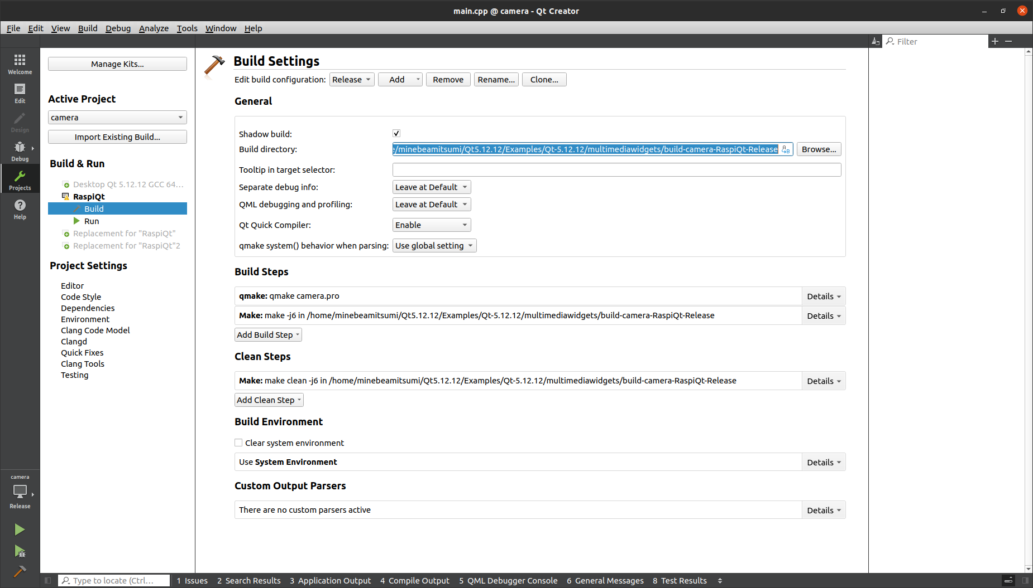

Open terminal and goto release directory
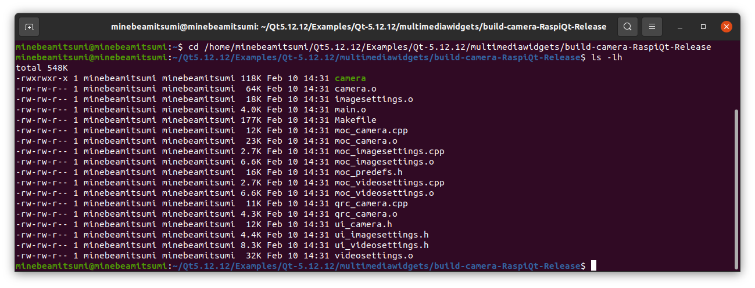

Copy binary file “camera” to raspberry pi device

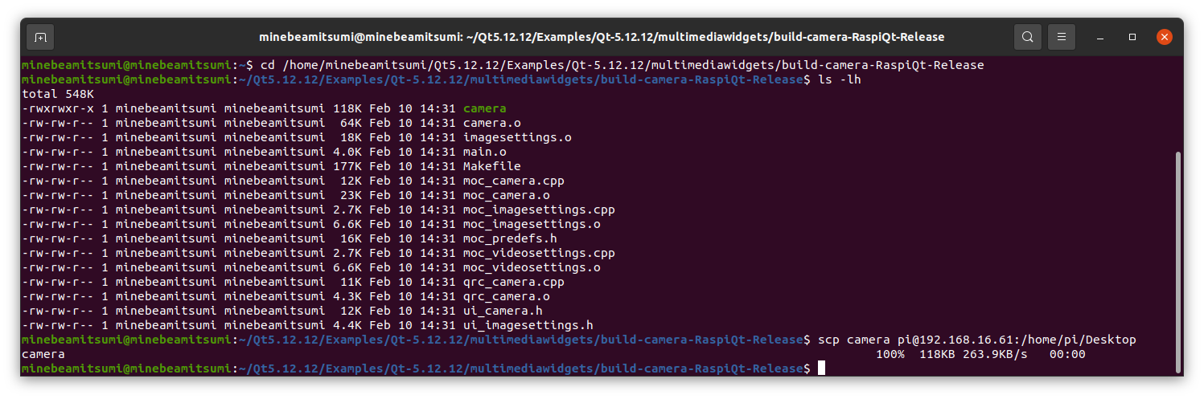
Check raspberry pi device “ssh pi@192.168.61.16” via host terminal.
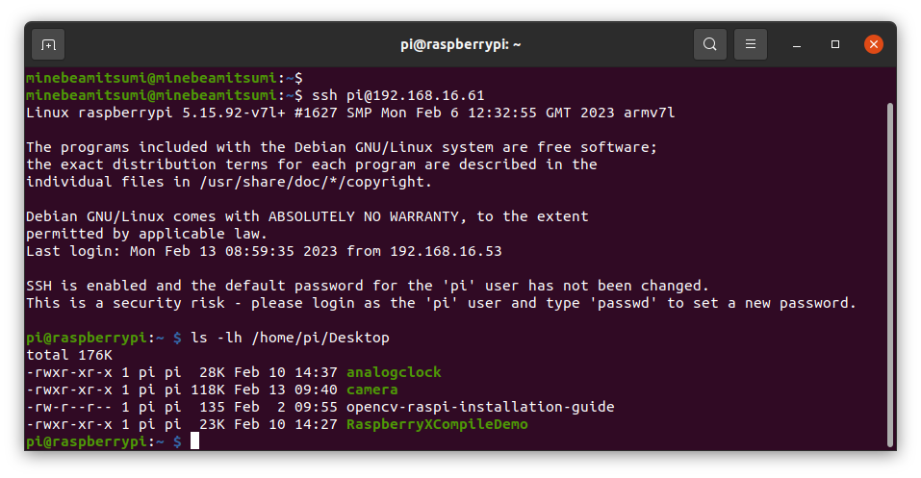
As we can see, the binary file camera copied on raspberry device.
Checking binary file execution. Open Raspberry Pi device via VNC.
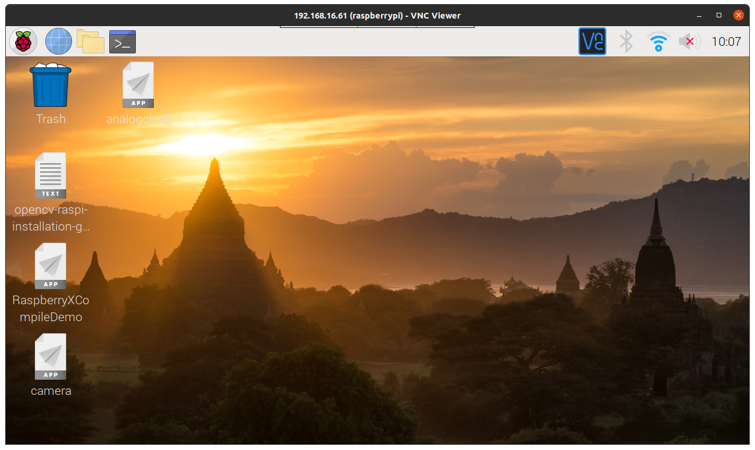

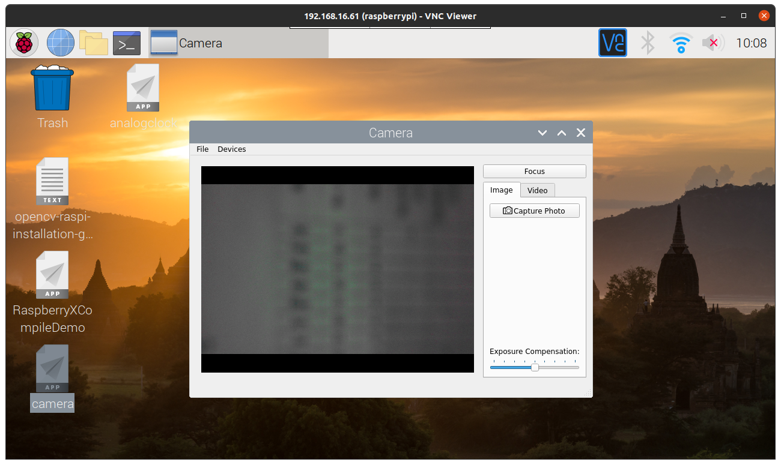
Final result of Cross Compilation on Raspberry Pi is successful.

After running examples from Qt creator, the OpenCVApplication that created must also deploy on Raspberry pi.

Setting Device for Raspberry Pi

Open Qt Creator -> Tools -> Option -> Devices

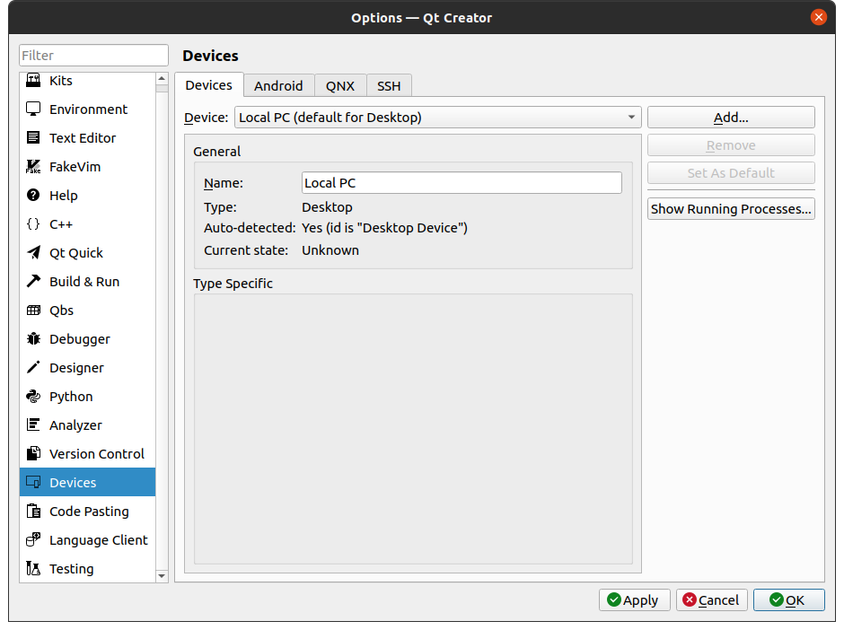

Click Add -> Select “Generic Linux Device” -> Click “Start Wizard”

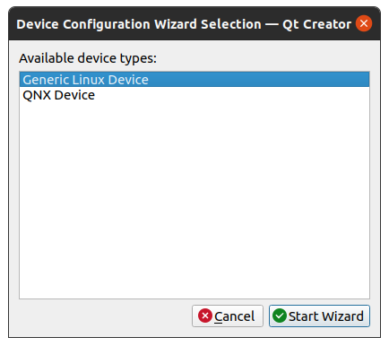

Connection:
Configuration: Raspberry Pi
IP Address: 192.168.16.61
Username into the device: pi

Click Next ->
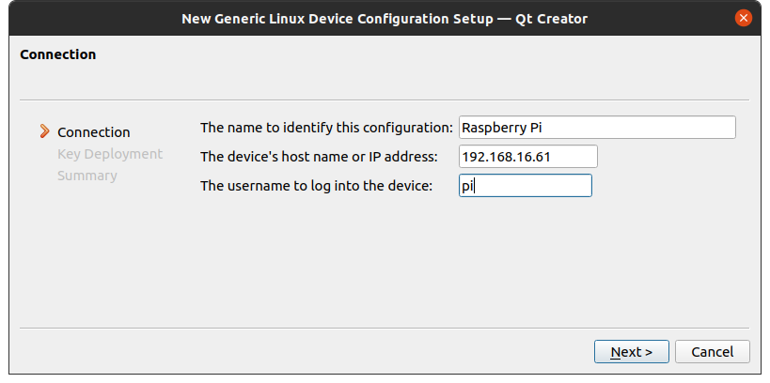

Establishing Connection Success on Rapsberry Pi device:
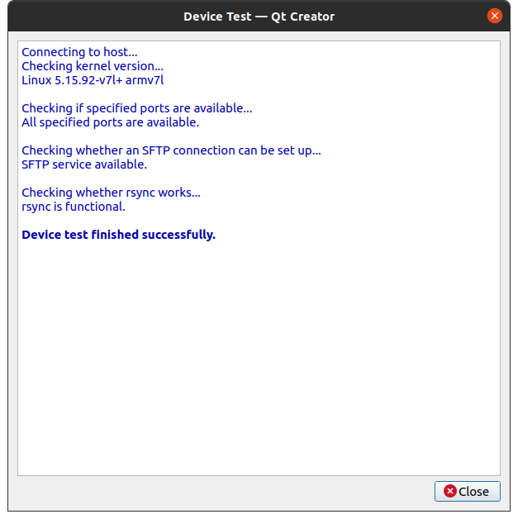

For OpenCV Development on Raspberry Pi

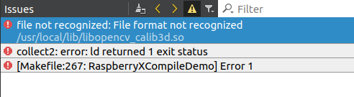
Note: After building Opencv ARM compiler for Raspberry Pi device you encounter this kind of error

make sure to link properly the .so library folder

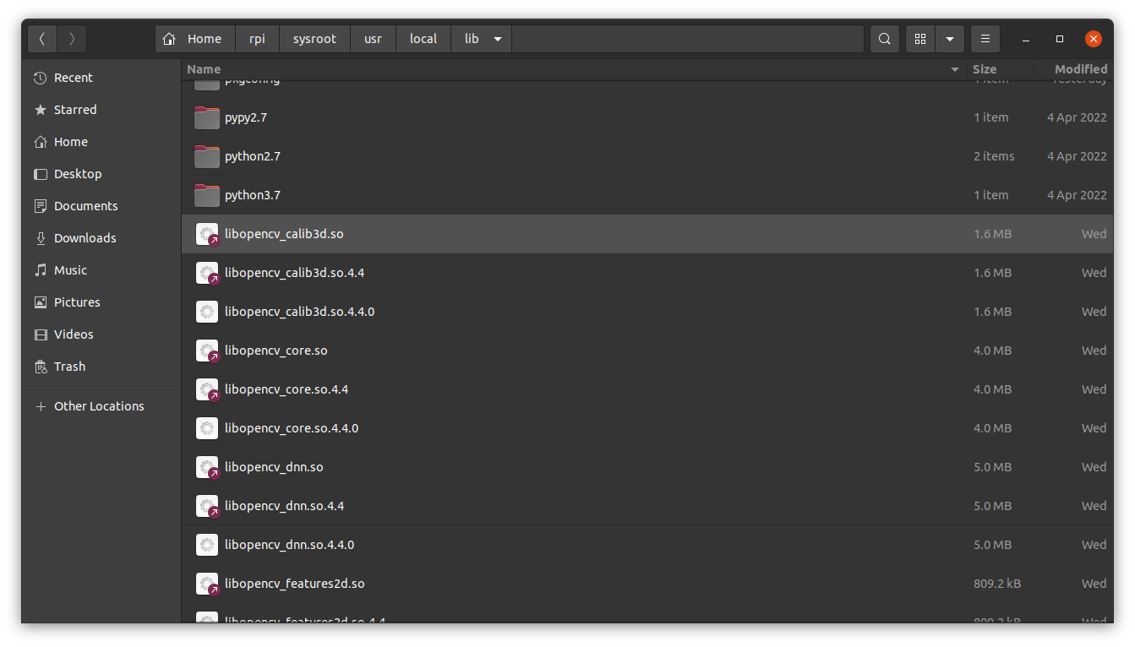

For complete Raspberry Pi Cross Compilation steps. Please refer to this link
https://github.com/manfredipist/RPi3BPlusQtOpenCV
same as my setup.

Using VNC app
Using USB2.0 Micro Camera

MainWindow
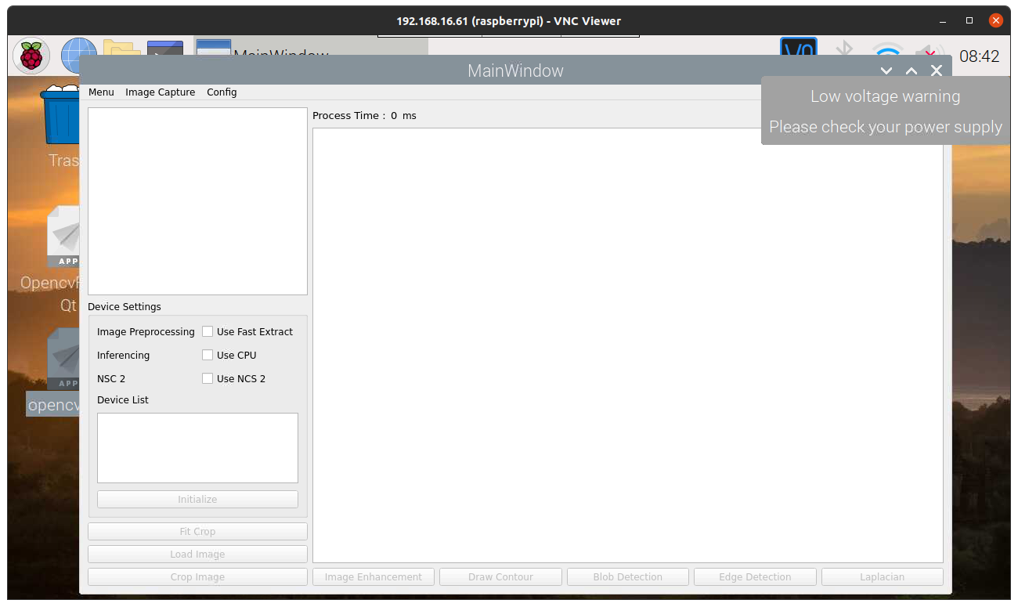

Camera feed
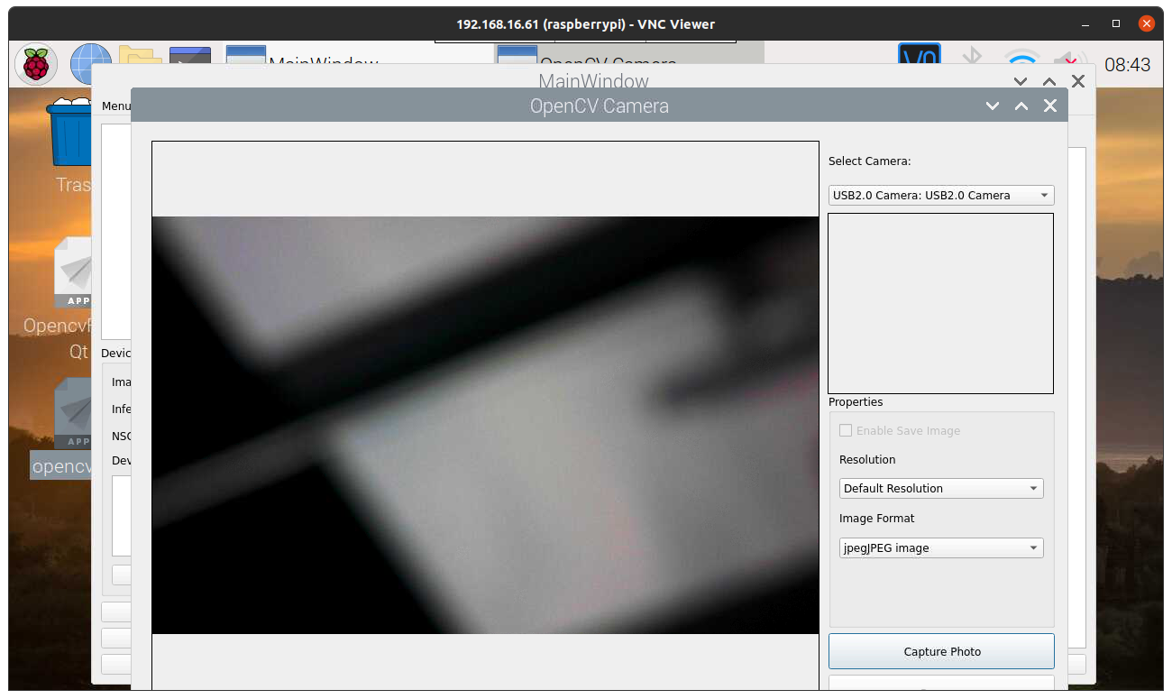

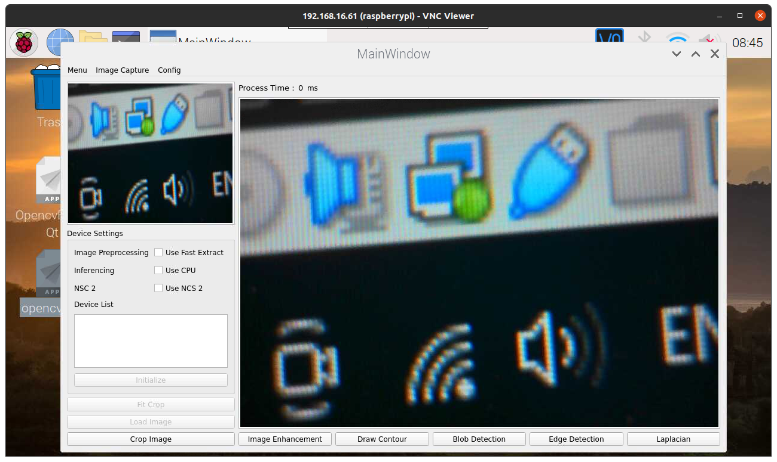
Image Capture

Blob Detection
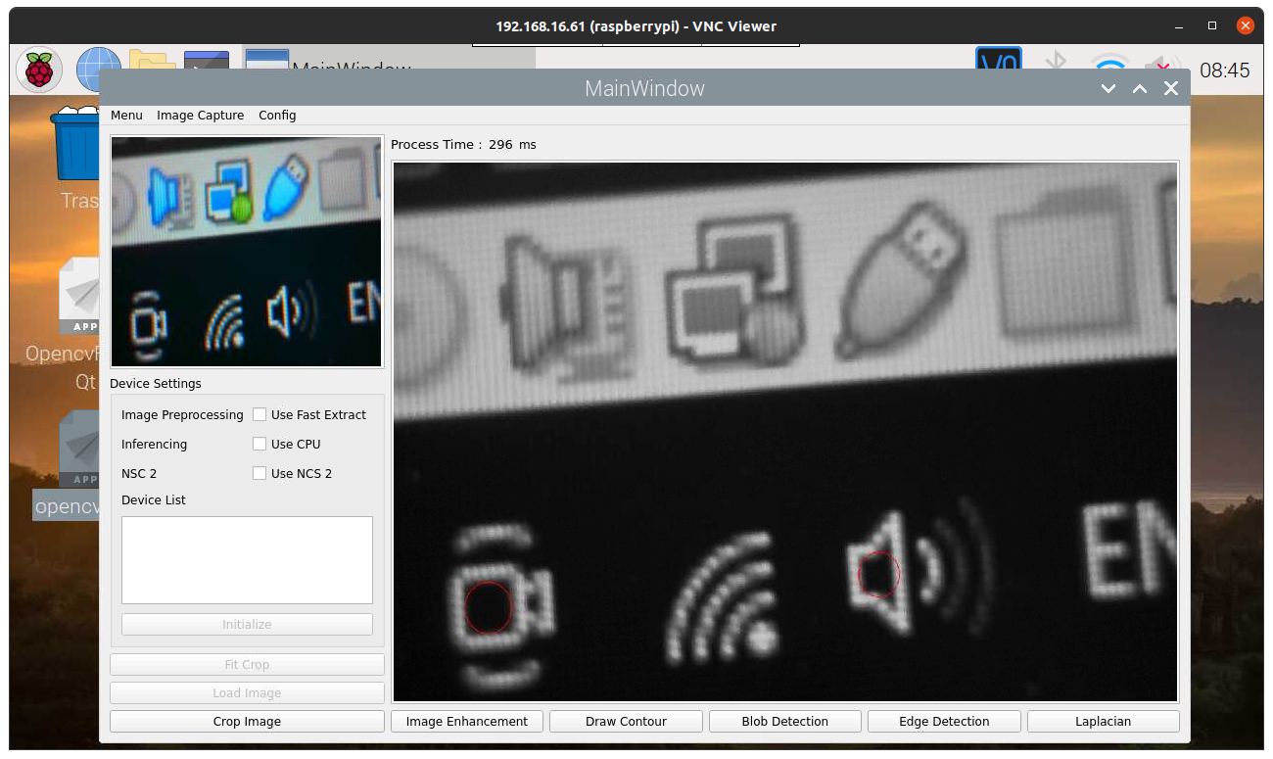

Image Enhancement (Brightness at 100%)
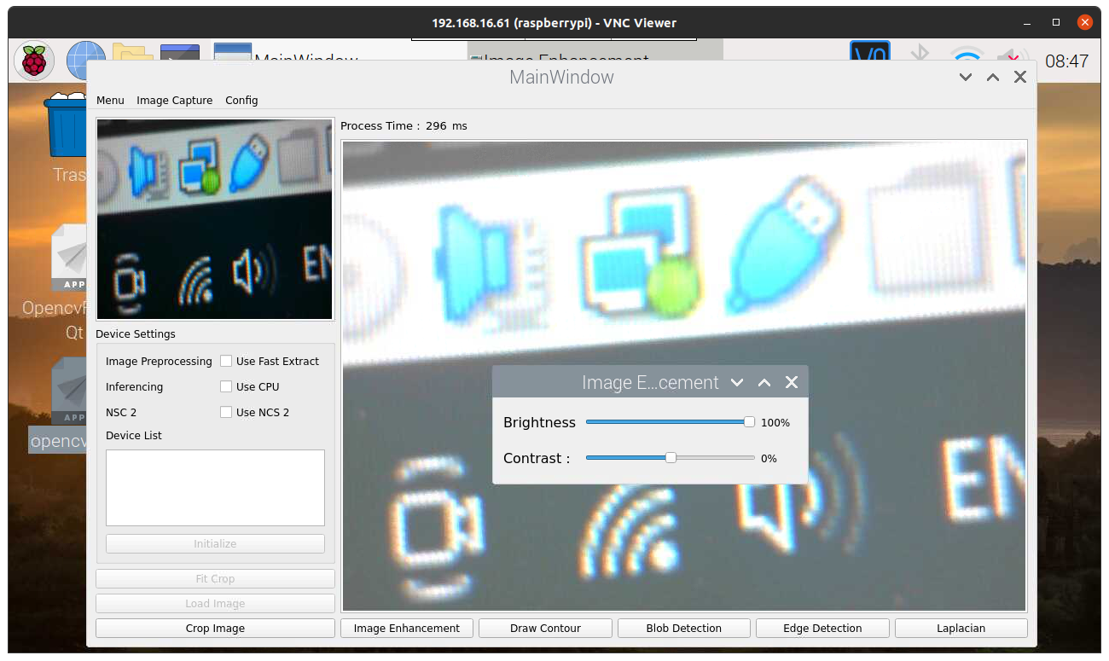

Image Enhancement (Brightness at -100%)
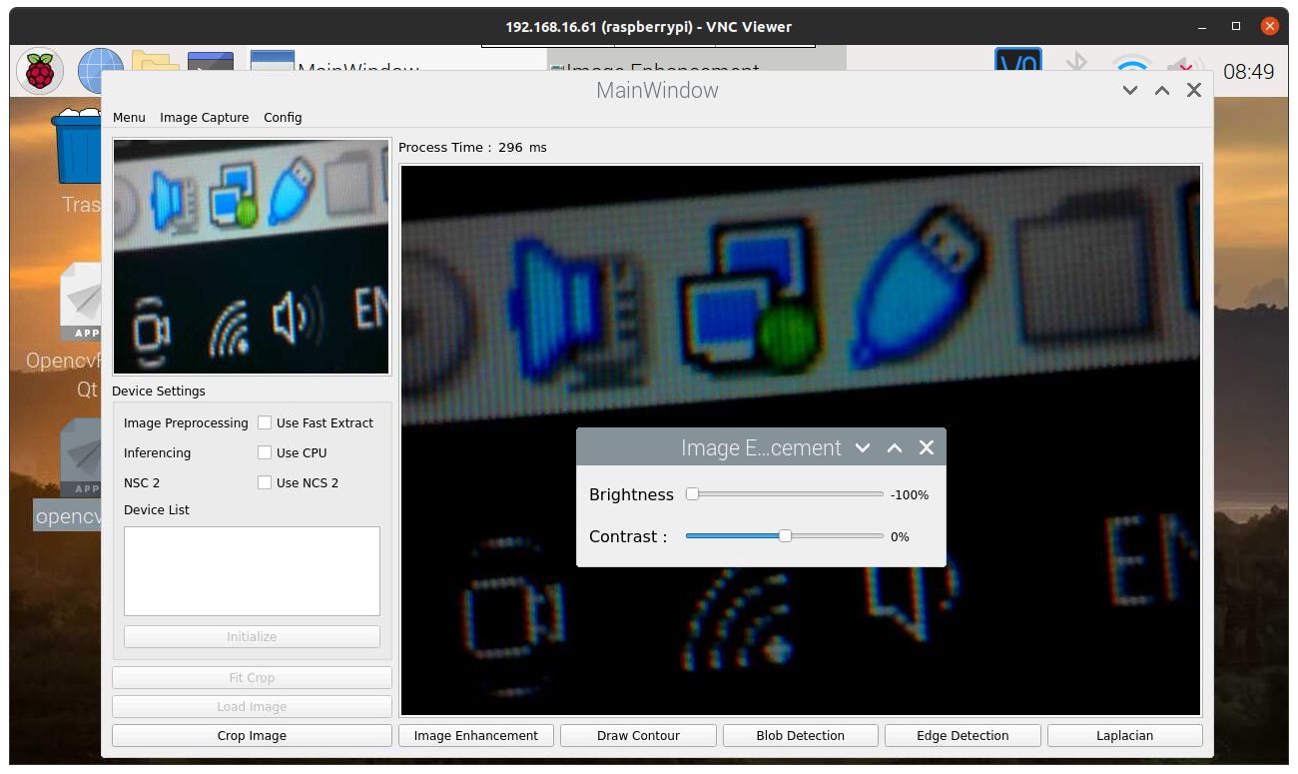

Image Enhancement (Contrast at 255%)
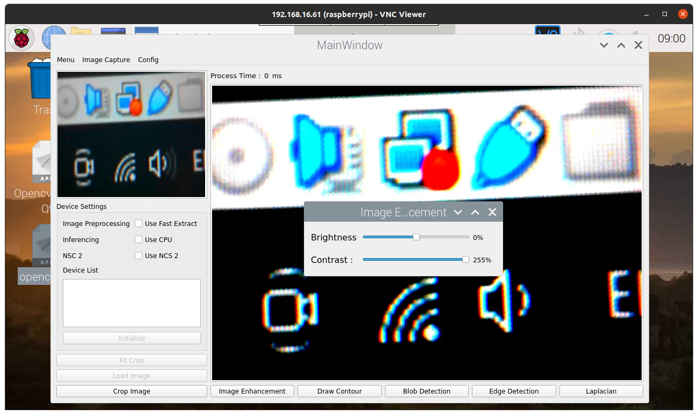
Image Enhancement (Contrast at -255%)
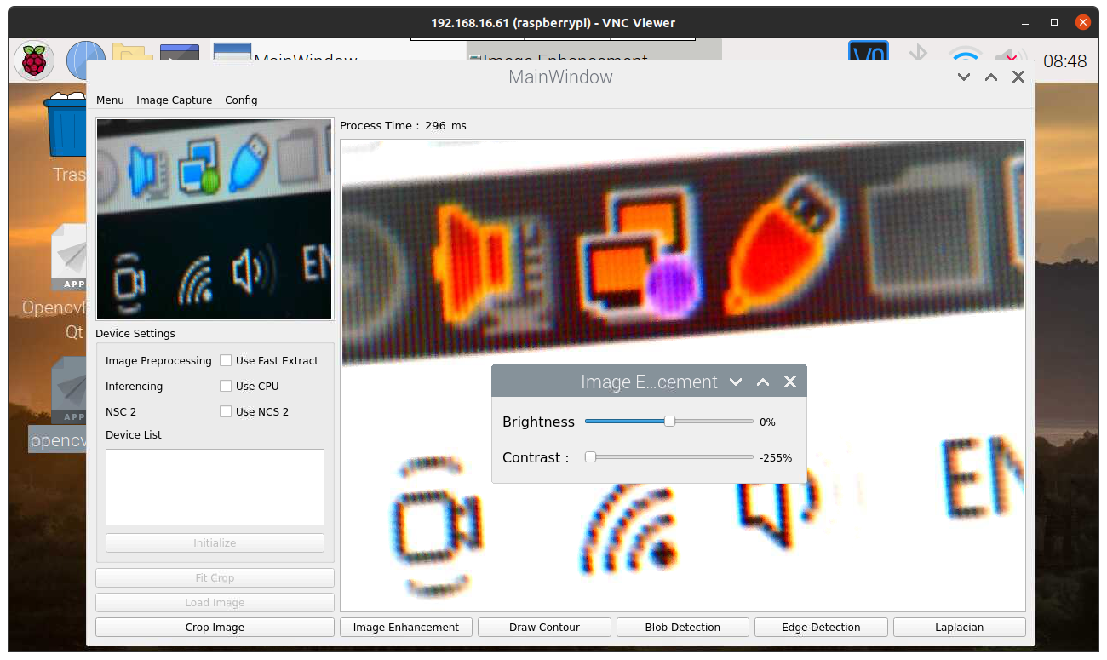

Crop Image
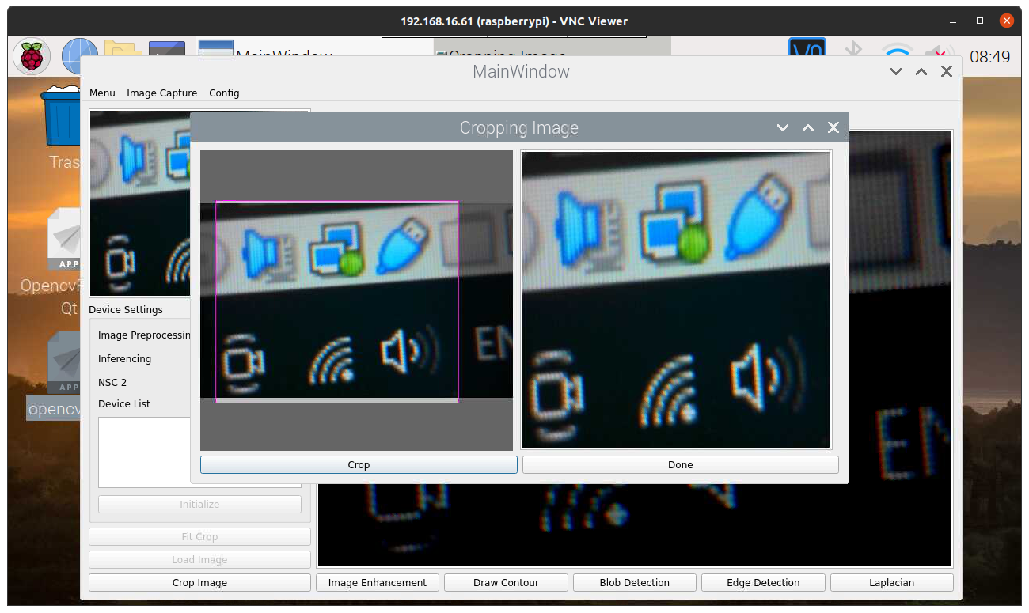

Draw Contour


